

** Cyprus** *Energy Union factsheet[1]*

1. **Macro-economic implications of energy activities**

Energy and transport are key sectors for the overall functioning of the economy as they provide important input and service to other sectors. The combined activity of these two sectors[2] accounted for 9.1% of the total value added of Cyprus in 2015. Similarly, their share in total employment[3] was 4.7% in 2015, of which 4.3% in the transport sector and 0.4% in the energy sector.

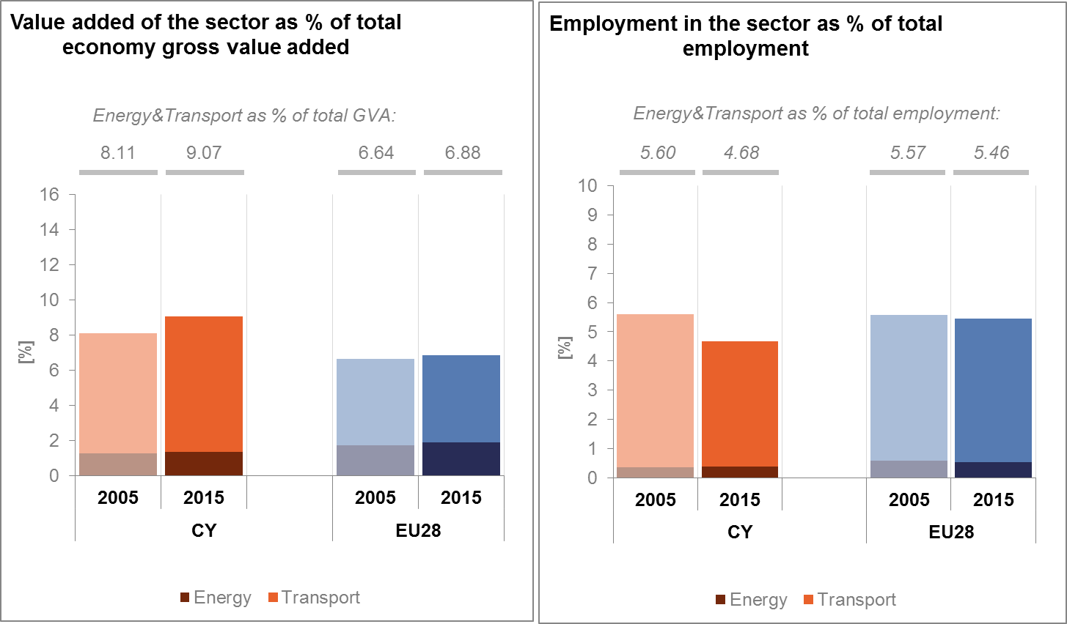

*(source: Eurostat)*

The decarbonisation of the energy and transport sectors will require significant investments and economic activity beyond the remit of these sectors themselves. The energy transition implies a structural shift in economic activity. Energy-related investment and jobs will in part migrate from traditional fossil fuel based activities towards construction, equipment manufacturing and other services related to the deployment of low carbon and clean energy technologies. At the moment, the efforts related to the low-carbon and clean energy transition in sectors beyond energy can only be partially quantified and are therefore not included in this analysis.

In the case of renewable energy sector, both the direct as well as the indirect effects on employment are being estimated. According to EurObserv'ER, in 2015, the share of direct and indirect renewable energy related employment in total employment of the economy in Cyprus was at about 0.17%, well below the EU average of 0.54%. The turnover of the renewable energy industry in the same year was estimated at around EUR 65 million, with wind and photovoltaic contributing most.

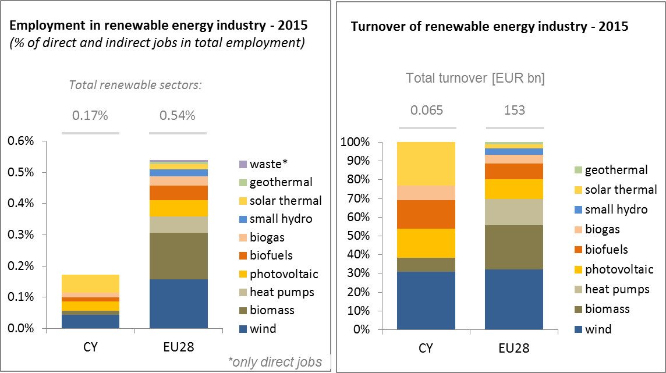

*(Source: EC based on Eurobserv'Er and Eurostat)*

Cyprus is nearly fully dependent for its energy consumption on the imports of fossil fuels, currently almost exclusively refined petroleum products. This dependency has led to a much larger trade deficit in energy products than for the EU as a whole. The energy trade deficit as share of GDP in 2015 is 4.1% of GDP, and thus almost 1 percentage point of GDP lower than in 2006 (5%). The decrease is almost completely accounted for by the trade deficit for petroleum products. The underlying structural causes for this decrease are lower prices of fuels and increase in re-export of fuels.

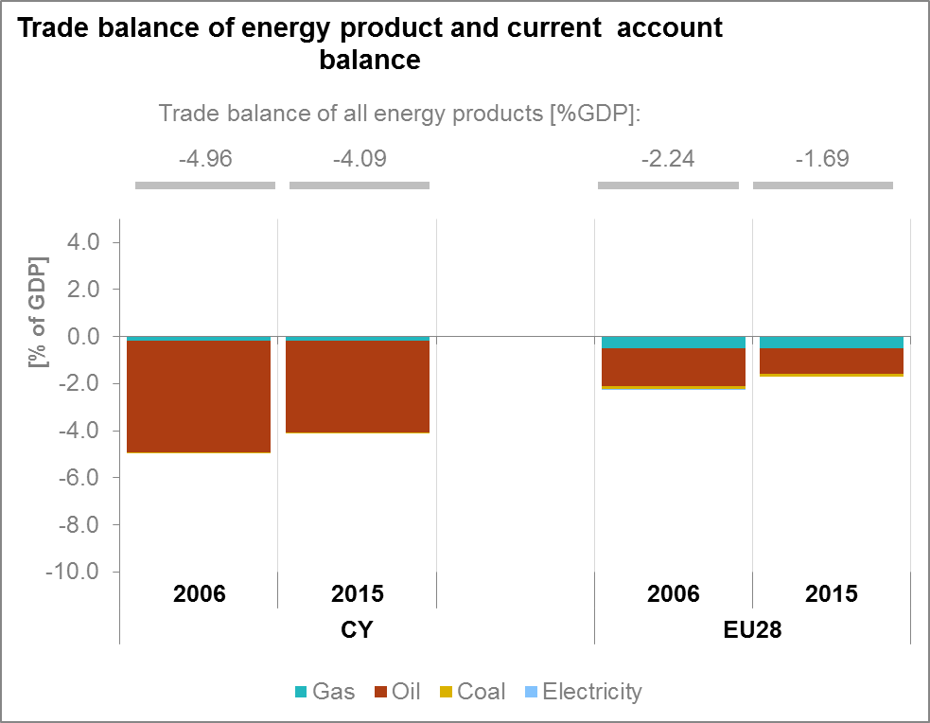

*(Source: Eurostat)*

1. **Energy security, solidarity and trust**
   1. **Energy Mix and security of supply**

Renewable energy (wind, solar and biomass) represented a share of 6.5 % of primary energy gross inland consumption for Cyprus in 2015; the rest comes essentially from oil products (92.8%). This unbalanced energy mix exposes Cyprus economy to the fluctuations of international oil prices, and creates vulnerability. There are plans to supply the island with natural gas, which would make the energy sector cleaner and less expensive, but no final investment decision has been made public to date.

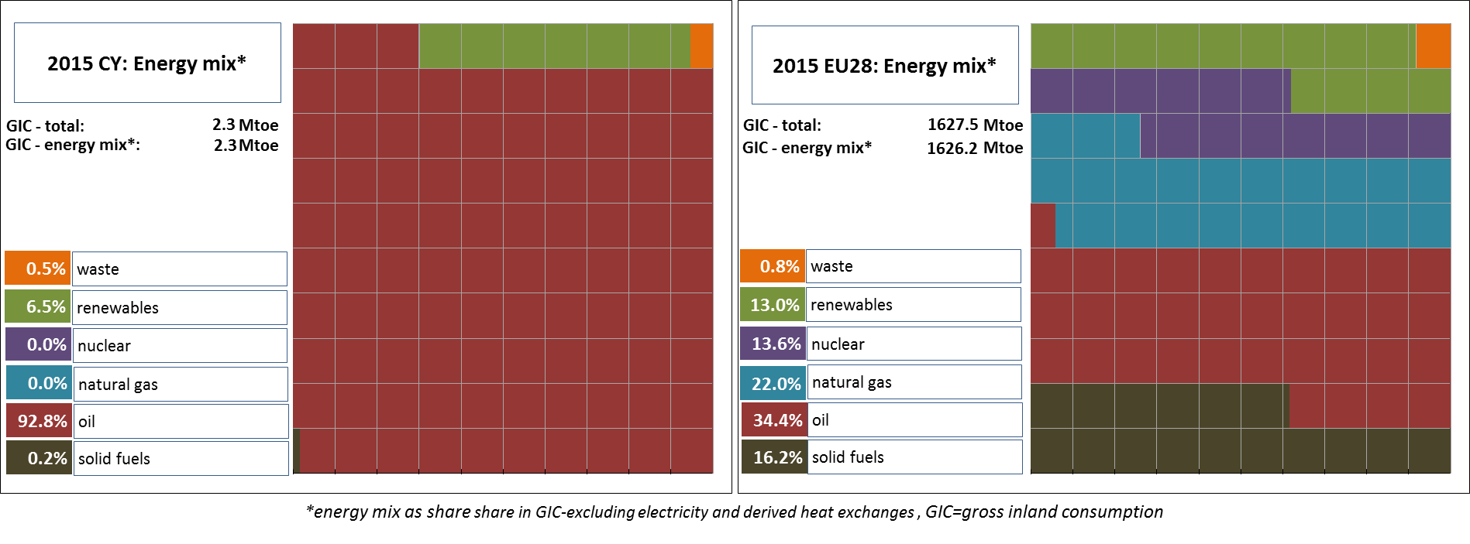

*(source: Eurostat)*

* 1. **Import dependency**

Cyprus has no known oil resources and no refineries; therefore all oil products are imported. In fact, Cyprus imports more oil products than it consumes, because a non-negligible amount is used in refuelling ships and planes and also for maintaining emergency oil stocks on national territory. Developing Cyprus' substantial RES potential would certainly improve dependency as well as trade deficit, air quality and employment in renewable energy industry.

A significant gas field (Aphrodite) was discovered a few years ago within Cyprus Exclusive Economic Zone (EEZ). However no final decision on exploitation of the Aphrodite field has been made public to date. Further exploration activity is in progress.

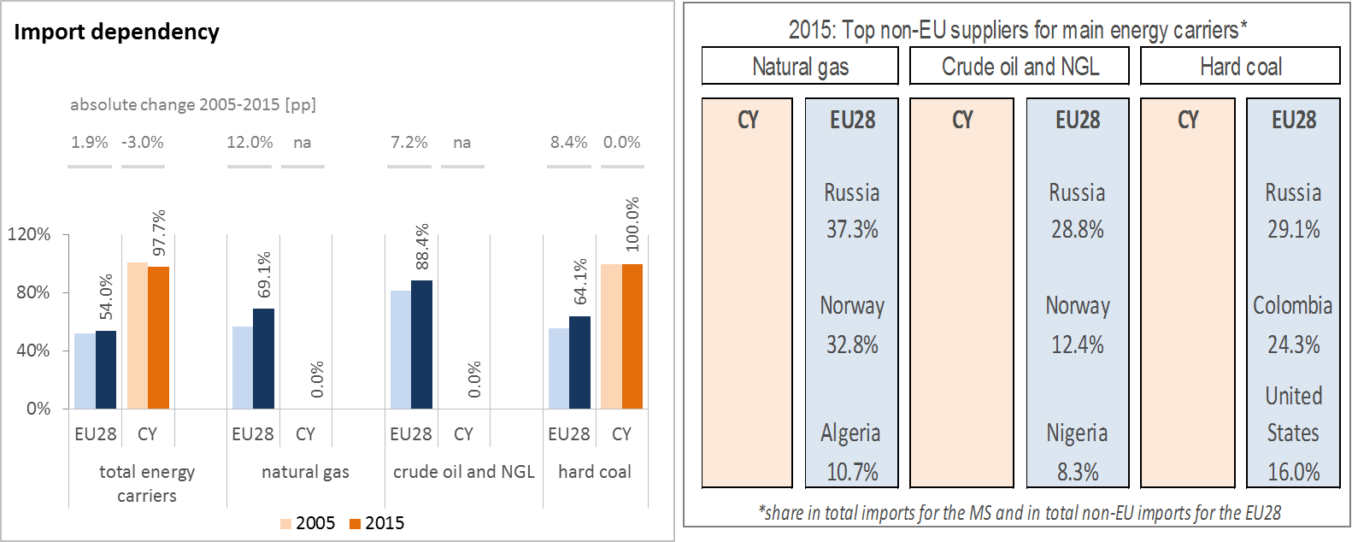

*(source: Eurostat)*

1. **Internal market**
   1. **Interconnections and wholesale market functioning**
      1. **Electricity**

|  |  |
| --- | --- |
|  | |
| *(sources: EC services based on Eurostat)* |  |

The island is not interconnected with any other country; there is no wholesale electricity market either, since the public electricity supplier (EAC) operates as a *de facto* monopoly. A few RES generators sell all production to EAC by means of long-term Power Purchase Agreements. Supply prices are regulated by the Cyprus Energy Regulatory Authority.

Cyprus has a potential in terms of energy resources in the Eastern Mediterranean. Given its geographical location and isolation from EU grids and in line with EU energy policy and the goals of the Energy Union, Cyprus identified four projects within the Project of Common Interest (PCI) process since 2013.

Since 2014, a total EUR 15.8 million has been granted under Connecting Europe Facility (CEF) to investigate the feasibility of a subsea electricity cable, "EUROASIA Interconnector", composed of three sections connecting respectively: Israel to Cyprus; Cyprus to Crete and Crete to continental Greece. When materialized the project will end Cyprus' electricity isolation and greatly improve grid reliability and stability and enhance security of energy supply. It could also facilitate the transmission of electricity generated using gas from the fields in the Eastern Mediterranean and electricity produced from Renewable Energy Sources.

As far as natural gas is concerned CEF supports three projects: a) a pipeline from offshore Cyprus to Greece mainland via Crete, known as the EastMed Pipeline: b) an LNG storage facility, currently known as the “Mediterranean Gas Storage”; c) an action aimed at removing internal bottlenecks in Cyprus to end isolation and to allow for the transmission of gas from the Eastern Mediterranean region.

* + 1. **Gas**

As stated above, currently there is no natural gas in Cyprus and therefore no market. Following a decision taken by the Council of Ministers, the Cyprus Natural Gas Company (DEFA) is investing potential options to import Liquefied Natural Gas (LNG) to Cyprus by the year 2020.

* 1. **Retail electricity and gas markets**

As already explained, there is no natural gas in Cyprus and therefore no market. Electricity Authority of Cyprus (EAC) is currently the sole supplier; therefore there is no retail electricity market either and no switching.

* + 1. **Electricity**

The largest share of Cyprus electricity is generated in oil burning power plants; as a consequence retail prices depend, although indirectly on fluctuations in world oil prices, by means of a "*Fuel Adjustment Clause*" incorporated in the tariff structure. Prices dropped substantially in 2016, and are now below prices paid in most EU countries.

There are plans to start the implementation of the mass rollout of smart meters at the end of 2017 / beginning of 2018. Reading is currently manual, except for large consumers.

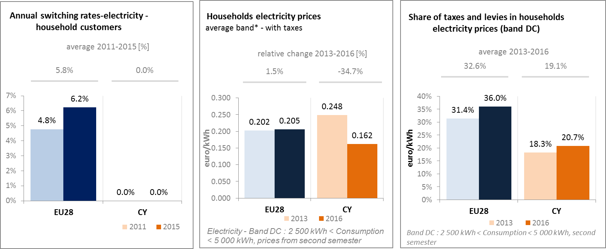

*(source: ACER) (source: Eurostat) (source: Eurostat)*

* + 1. **Market performance indicators**

The periodical survey of the European Commission shows a Market Performance Index of 73.2, slightly lower than for the EU average. This shows a perception of the quality of the services received on electricity retail markets lower for Cypriot customers than for the EU average consumer. No data is available for natural gas since there is no gas retail market.

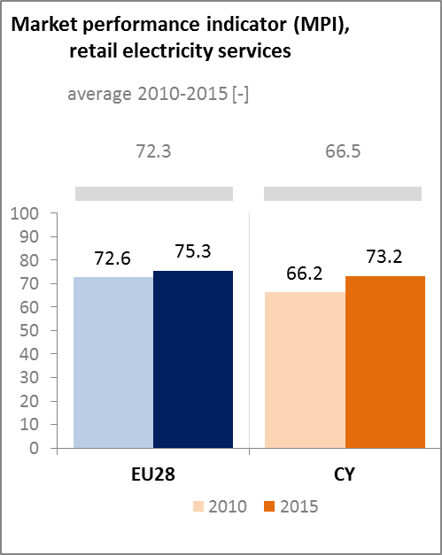

*(source: DG JUST survey)*

* 1. **Energy affordability**

In Cyprus, warm climate conditions imply heating needs limited to a few months per year. In spite of that EU-SILC survey (Eurostat) mentions that 49.2% of the population at risk of poverty claim an "*Inability to keep home adequately warm*".

Overall, the share of energy expenditure in total budget for the poorest consumers in Cyprus is much lower than for the EU average, notably reflecting the specific weather conditions.

EAC, the sole retail supplier provides for a "*Special Tariff for Specific Categories of Vulnerable Customers*".

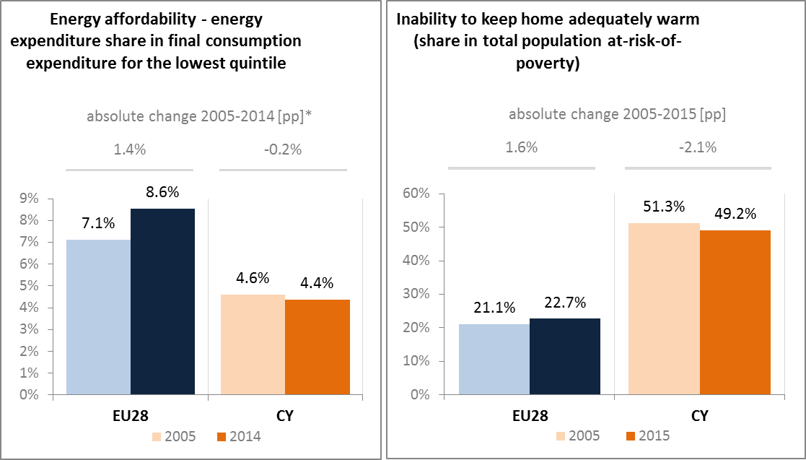

*\*data for energy affordability in Cyprus are from 2005 and 2009*

*(source: ad-hoc data collection of DG ENER based on HBS with the support of Eurostat and national statistics)*

1. **Energy efficiency and moderation of demand**

Since 2005, Cyprus' primary energy consumption decreased from 2.47 Mtoe in 2005 to 2.25 Mtoe in 2015. Over the same period, final energy consumption also decreased from 1.8 Mtoe in 2005 to 1.66 Mtoe in 2015.

The 2020 indicative target of 2.2 Mtoe primary energy (and 1.9 Mtoe final energy consumption) appears within reach, provided that the energy efficiency policies adopted in Cyprus will be more intensively implemented in the following years. In this context, the national energy efficiency plans, actions and programs need to be effectively implemented in order to meet the indicative target for primary energy for 2020 as well as the obligation for cumulative energy saving requirements by 2020, stemming from Article 7 of the Energy Efficiency Directive.

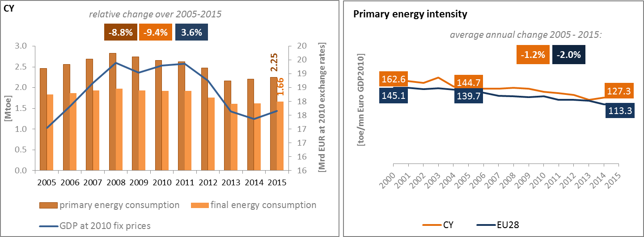

*(source: Eurostat)*

Transport (road and aviation) represents the largest share (52%) of Cyprus final energy consumption and it would make sense to concentrate there the efforts, provided that this would be technically feasible and economically effective.

Cyprus aims to reduce the building sector’s energy demand to a very low level, for both new and existing buildings, by implementing all financially and technically feasible measures, in particular as regards leading Cyprus into a smooth transition towards Nearly Zero Energy Buildings.

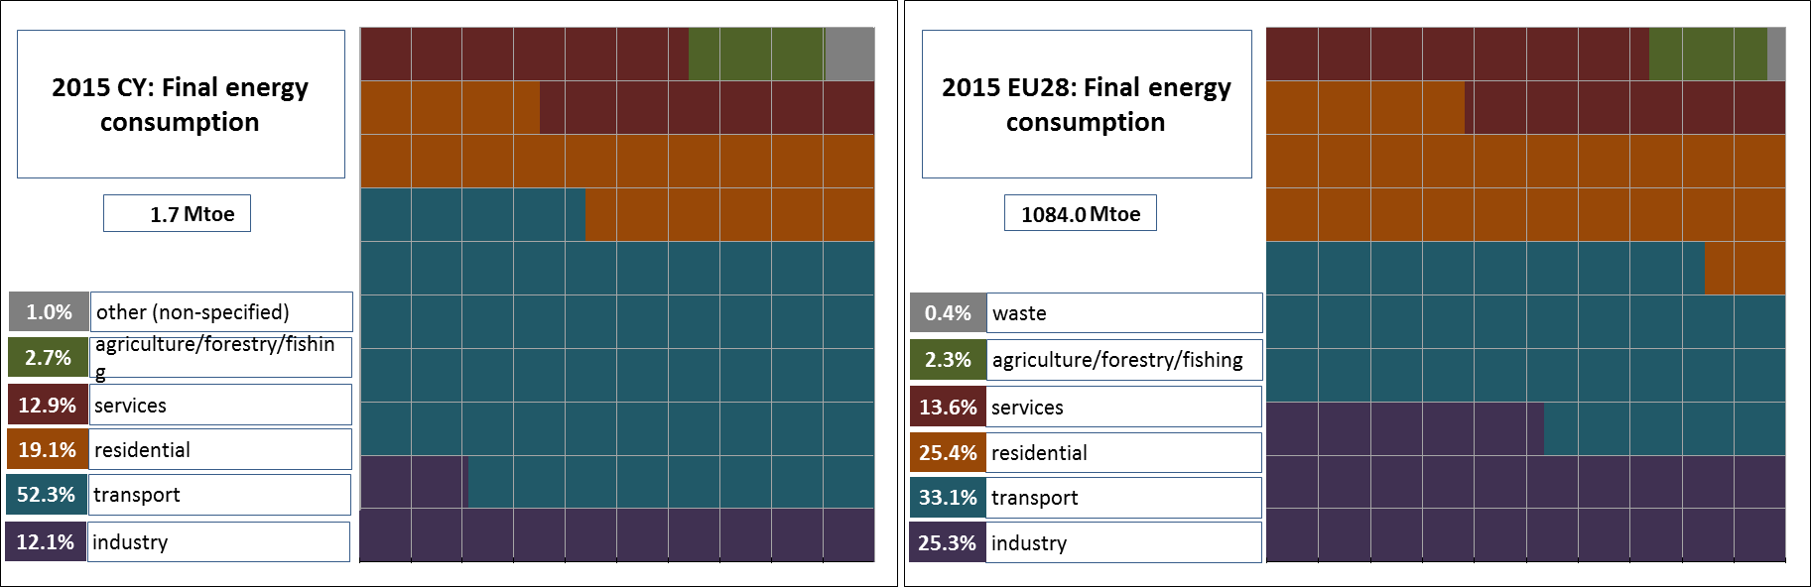

*(source: Eurostat)*

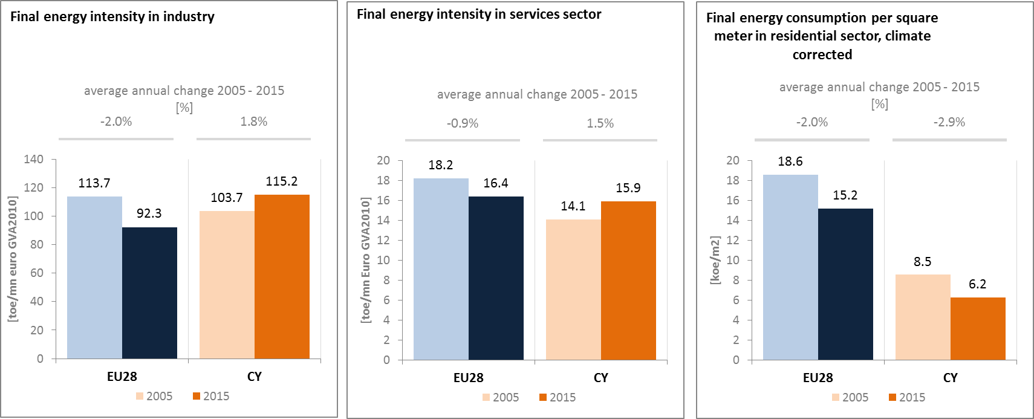

*(source: Eurostat) (source: Eurostat) (source: Odyssee database)*

In the transport sector, the final energy consumption decreased over the period 2005-2015, while GDP increased by 0.4% per annum on average. This hides significant differences in trends between passengers and freight transport activity. Passengers transport activity increased by 26% compared to 2005, while freight transport activity decreased at 40% of what it was in 2005. Overall, this led to a decrease in energy consumption by the transport sector. However, the share of collective passengers land transport has decreased, indicating a higher use of private transport.

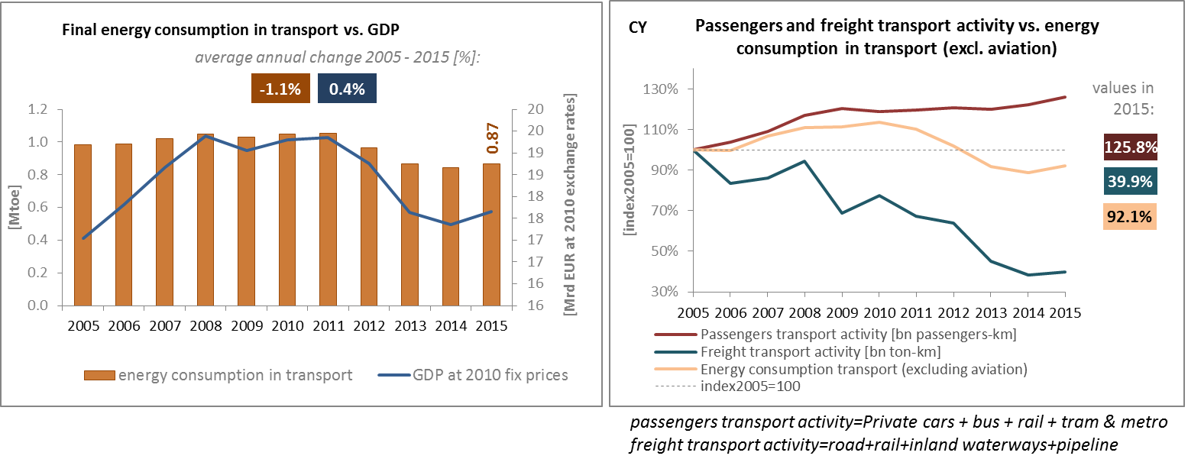

*(source: Eurostat) (source: Eurostat and DG MOVE pocketbook)*

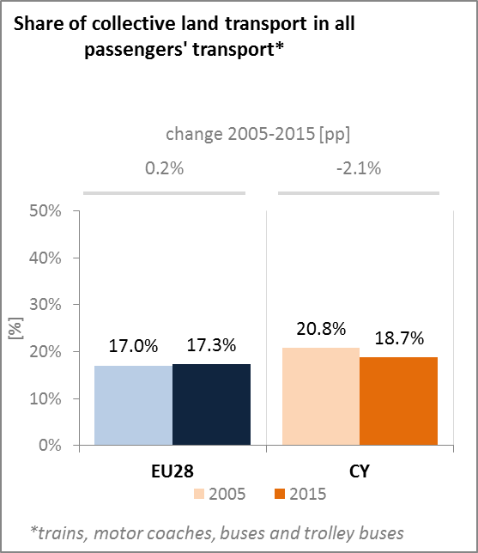

*(source: Eurostat)*

Transport policy merits attention as Cyprus is highly reliant on private road transport, as it is among the Member States with the highest motorisation rate in the European Union. The country is aiming to fulfil the commitments on GHG emissions through the reduction of its dependency on fossil fuels, including in transport. This involves the promotion of renewable energy sources, energy efficiency and climate-friendly technologies. Cyprus is currently promoting the use of LPG in vehicles. A relevant new law has come into force and a very small number of owners are currently using LPG for their vehicles.

One objective is to shift passenger traffic from private cars to public transport, where particular emphasis is given to the use of intercity and rural buses by upgrading and modernizing the bus fleet, merging and expansion of the private bus companies, planning of new bus stations at the outskirts of the urban areas, and adopting integrated ticketing. Moreover, with the adoption of the “Sustainable Urban Mobility plans” Cyprus intends to promote the use of sustainable modes of transport (e.g. walking, cycling, public transport) and discourage the use of private cars.

1. **Decarbonisation of economy**
   1. **GHG emissions**

According to its projections, Cyprus will achieve in 2020 its greenhouse gas emission reduction target in the sectors outside the EU ETS by a margin of 9.5 pps.

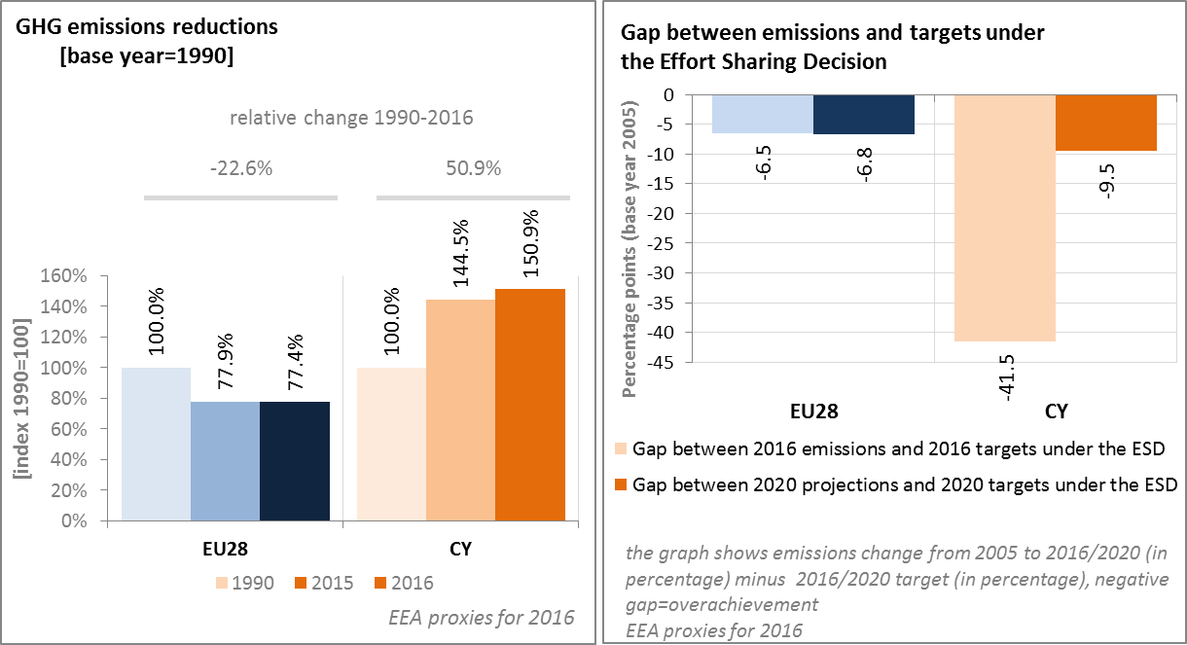

*(source: EC and EEA)*

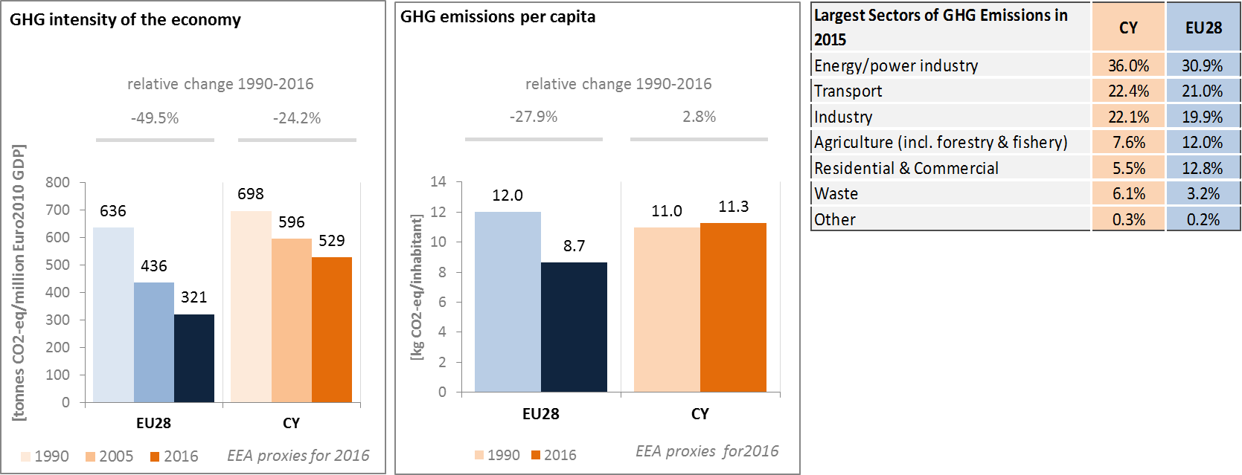

*(source: EC and EEA)*

On accounted emissions and removals from land use, land use change and forestry there are currently no available data for Cyprus.

**CO2 emissions in transport and alternative fuelled vehicles**

CO2 emissions from road transport are 56% higher than in 1990 in Cyprus. They have only slightly decreased since 2005. Average CO2 emissions from new cars registered in Cyprus have decreased by around 29% since 2005. In 2016, average CO2 emissions from new cars were 123,5 g CO2/km (EU fleet-wide target is 130 g CO2/km since 2015 and will become 95 CO2/km from 2021 on).

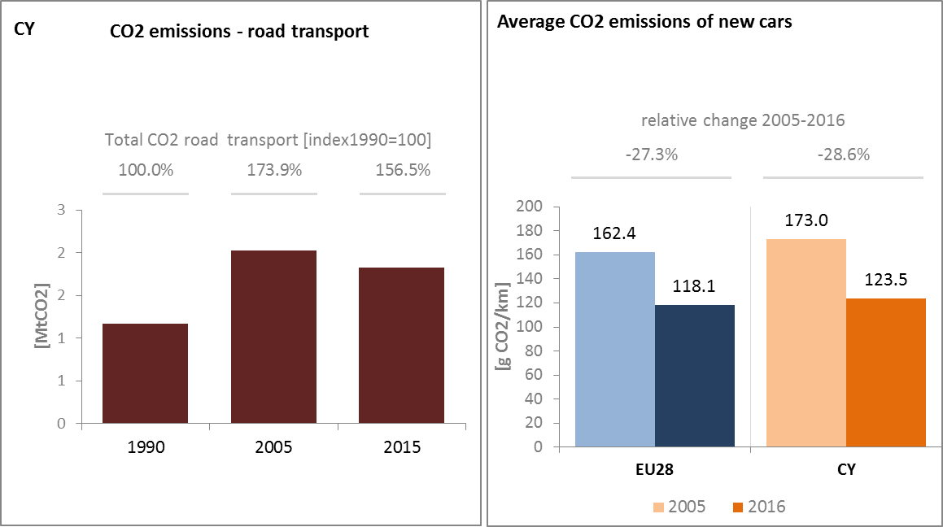

*(source: European Environment Agency)*

According to the 2016 data available, Cyprus has 36 publicly accessible electric charging points.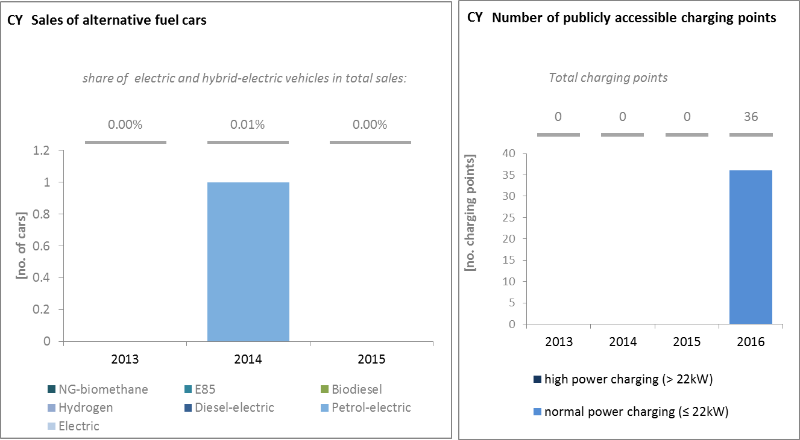

*(European Environment Agency) (European Alternative Fuels Observatory)*

National Policy Frameworks under Directive 2014/94/EU on alternative fuels infrastructure have to establish targets, objective and measures for the development of the market of alternative fuels in the transport sector and the deployment of the relevant infrastructure. Cyprus has submitted its National Policy Framework as requested under article 3 of the Directive 2014/94/EU.

A detailed assessment of the Cypriot National Policy Framework in terms of its compliance with the requirements of Directive 2014/94/EU on alternative fuels infrastructure, its contribution to achievement of long-term energy and climate objectives of the Union and coherence of its targets and objectives in terms of cross-border continuity has been published as part of the Communication on Alternative Fuels Action Plans (COM(2017)652) and  the related staff working document SWD(2017)365.

Cyprus is also planning to contribute to lower CO2 emissions from marine transport by developing a liquefied natural gas (LNG) bunkering facility, which may be built in Limassol.

* 1. **Adaptation to climate change**

Cyprus adopted its National Adaptation Strategy in 2017. The National Adaptation Action Plan had already been published in 2014 and was incorporated into the NAS, so the NAS and NAP are presented as one document. Vulnerable sectors that have been identified comprise water, agriculture, soil resources, fisheries and aquaculture, forestry, biodiversity, public health, tourism, coastal zones, energy and infrastructure. A Monitoring Strategy has been developed to complement the NAS, in which a Monitoring Team was suggested. Monitoring reports are scheduled every year from 2017 to 2019 but nothing has been published so far.

* 1. **Taxes on energy and transport and fossil fuel subsidies**

Cyprus does not have a carbon tax in place, but both the car registration tax and car ownership tax depend on CO2 emissions performance. This is significant since Cyprus has a relatively large and old car park.

The overall tax burden on energy and transport in relation to GDP in Cyprus was 3.1% in 2014, which was about 0.7 p.p. higher than the EU average. It represent a very slight decrease compared to 2007.The tax burden on transport in Cyprus has shifted from taxes on vehicles to taxes on transport fuels, resulting in about halving the tax burden of the former, while leaving the overall tax burden on transport nearly unchanged. The burden of fuel taxation now exceeds the EU-average in line with the strong reliance on imported petroleum products. In contrast, the taxation of heat and electricity, which was close to the EU average in 2007, has not followed the rise of the EU-average and is now lower.

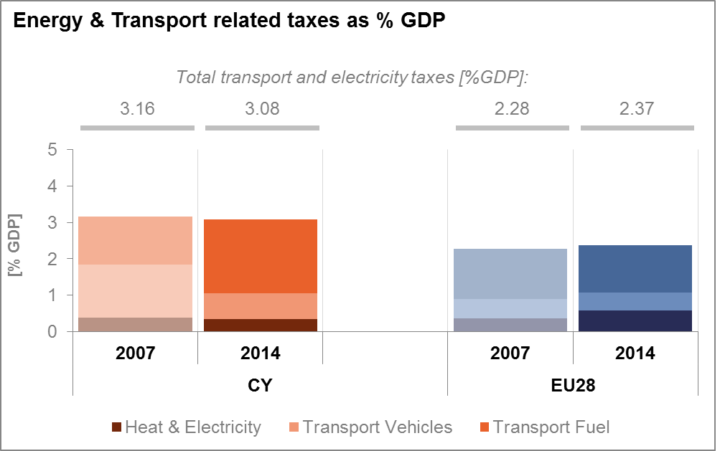

*(source: Eurostat)*

No data is available for Cyprus of the potential use of fossil fuel subsidies in the country.

* 1. **Renewable energy**

With a renewable energy share of 9.4 % in 2015, Cyprus appears on track to reach the target (13 % of gross final energy consumption) for 2020. It has met the third interim target of 7.45 %. However, since the trajectory is not linear, the final target will need to be achieved by means of a stronger annual growth of the renewable energy share, in line with Cyprus' high potential in this area.

Since 2013 Cyprus has abolished feed-in tariff support schemes for the production of electricity from renewable sources and a net metering and self-consumption scheme has been put in place. Access of electricity from renewable energy sources to the grid shall be granted according to the principle of non-discrimination. With regard to the use of the grid renewable energy shall be given priority. Grid development is a matter of central planning (Transmission Grid Development Plan 2007-2016 by the Cypriot TSO). In addition, renewable heating and cooling (RES H&C) is promoted by support schemes offering subsidies to enterprises and households respectively. Currently, in operation is a support scheme for the installation or replacement of solar hot water production systems for households.

There is number of policies aiming at promoting the development, installation and use of RES installations as well as specific RES H&C obligations. However the speed of new installations seems to have slowed down in the last few years.

Two concentrated solar power (CSP) supported by NER300 funds are currently under development. Helios Power (50 MW) reached final investment decision on 28 December 2016 but financing is currently on hold waiting for the negotiation of a power purchase agreement; entry into operation is planned for 31 December 2018. EOS Green Energy (50 MW) reached in principle final investment decision, but not a financial close as it is having difficulties securing all necessary loans. Entry into operation is planned for 30 June 2020.

With 2.5 % share in 2015, Cyprus is lagging behind in the use of renewable energy sources in transport and could have difficulty to reach the binding 10 % target by 2020; at the moment, there is no support scheme, or no public incentive, for the promotion of renewable energy in the transport sector in Cyprus.

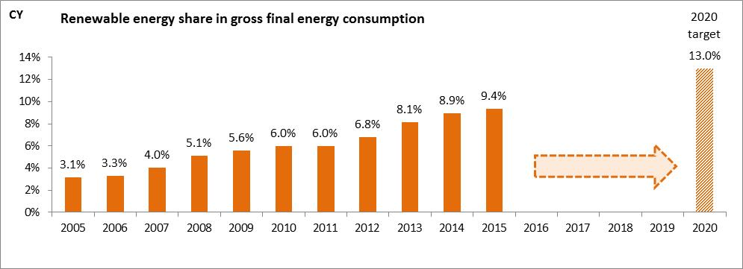

*(source: Eurostat-SHARES)*

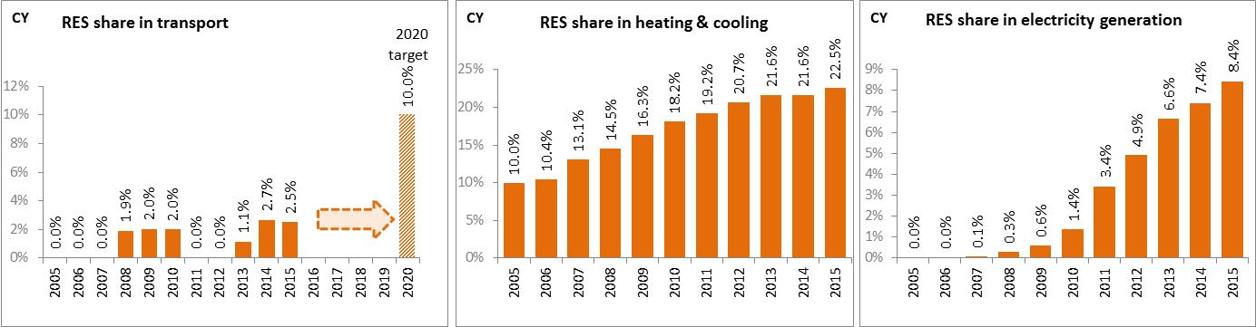

*(source: Eurostat-SHARES)*

Fossil fuels avoidance and GHG avoided emissions due to penetration of renewable energy sources remains substantially below EU average[4].

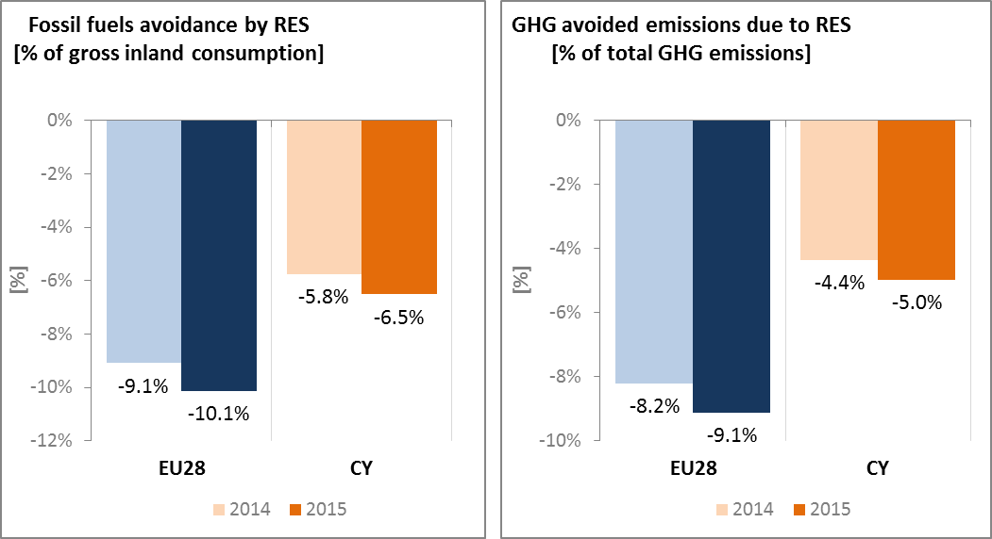

*(source: EEA)*

* 1. **Contribution of the Energy Union to better air quality**

Air quality in Cyprus is reported to be generally good, with exceptions. Nevertheless, for the year 2013, the European Environment Agency estimated that about 450 premature deaths were attributable to fine particulate matter (PM2.5) concentrations in Cyprus[5].

In 2015, Cyprus reported no exceedances of the binding EU air quality standards in the only air quality zone[6]; see below[7].

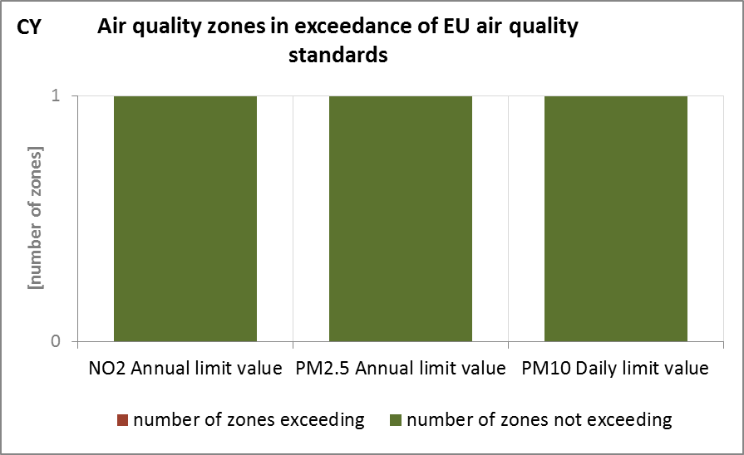

*(source: EEA)*

The health-related external costs from air pollution in Cyprus have been estimated to be more than EUR 549 million/year (income adjusted, 2010), which includes the intrinsic value of living a healthy life without premature death as well as the direct costs to the economy such as healthcare costs and lost working days due to sickness caused by air pollution[8].

The Energy Union can substantially contribute to further improve air quality in Cyprus through measures reducing emissions of both GHG and air pollutants such as PM and nitrogen oxides (NOx) from major contributing sectors such as (road) transport, energy production, industry and residential heating (e.g. stoves and boilers) as shown below[9].

This issue is particularly important in a country where tourism represents a significant share of GDP.

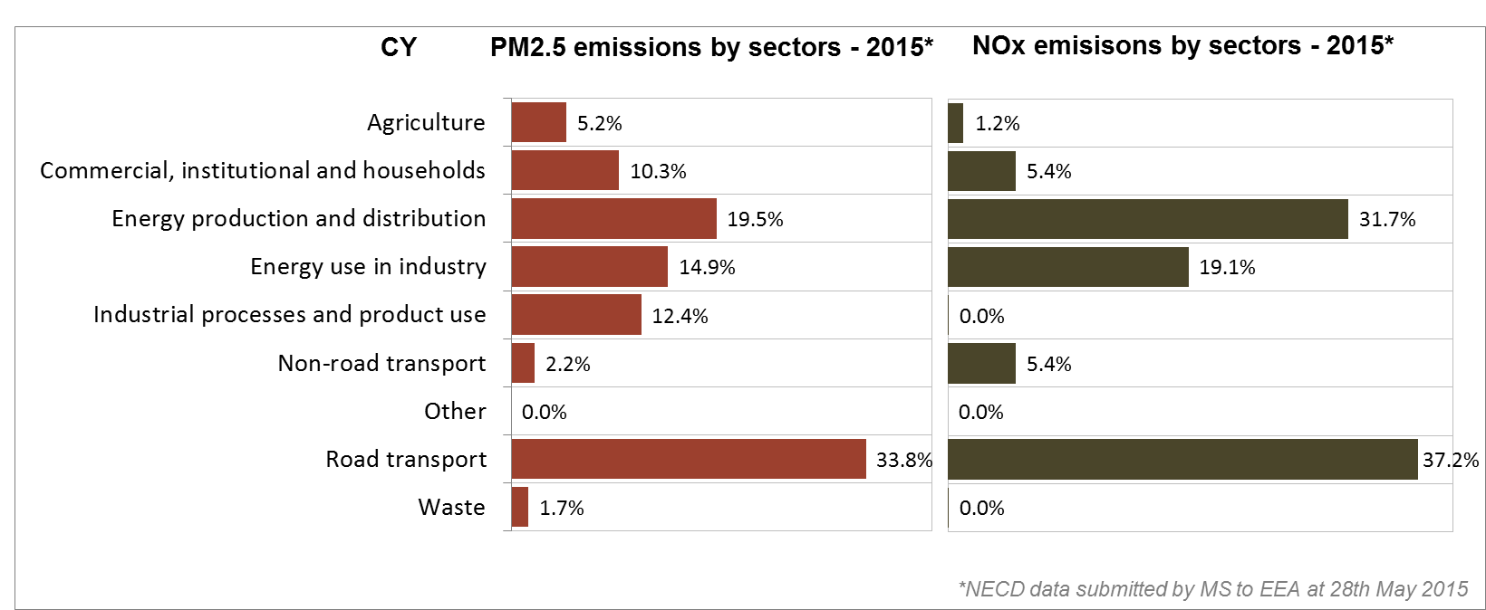

*(Source: EEA. This table reflects only sources of primary PM2,5 emissions.)*

1. **Research, innovation and competitiveness** 
   1. **Research and innovation policy**

Research policy is mainly implemented through the Research Promotion Foundation (RPF), established in 1996, which is the main research funding agency in Cyprus. Energy research in Cyprus focuses on wind, solar, geothermal, marine and biomass, as well as on the development of new renewable energy technologies related to energy production, transfer and storage. Other priorities include the improvement of energy technologies, and energy efficiency in industry, transport and buildings.

Energy research can be funded under the RESTART 2016-2020 Programmes of the RPF, a multi-annual development framework of Programmes for the support of Research, Technological Development and Innovation in Cyprus. Energy was identified as one of the dominant Priority Sectors of Pillar I of the RESTART 2016-2020 Programmes and is expected to play a major role in the next years. In contrast to Pillar I which deals with the implementation of specific targeted Programmes in the Priority Sectors, Programmes of Pillar II aim at addressing the needs of the RTDI System and enhancing its prospects. The Programmes focus around “excellence”, following a bottom-up approach meaning that participants may implement projects in the scientific or technological field of their choice including the Energy field.

Cyprus is active in the ongoing work of the Strategic Energy Technology (SET) Plan, taking part in twelve out of fourteen temporary working groups for the implementation of the integrated SET Plan.

Regarding the Horizon 2020 programme, Cyprus has received so far 0.2% of the EU contribution devoted to the 'secure, clean and efficient energy' part of the programme. As of September 2017, 28 participations from Cypriot organisations have been awarded EUR 4.2 million in Horizon 2020 energy projects. This includes two grants totalling EUR 0.5 million to Cypriot beneficiaries participating in project ZERO-PLUS (net zero energy settlements), and a grant of over EUR 0.4 million to the University of Cyprus for its participation in project GOFLEX (smart grids).

* 1. **Investments and patents in the Energy Union R&I priorities**

The European Commission does not have any data regarding the public (national) investments in the Energy Union R&I priorities.

Private investment in the Energy Union R&I priorities in 2013 was estimated at EUR 5 million (0.03% of the private R&I investment in Energy Union R&I priorities in the EU). The focus was on the Sustainable Transport and Efficient Systems priorities, which received 51% and 49% of the private R&I investments respectively.

In 2013, the most recent year for which complete patent[10] statistics are available, 2 companies and research organisations based in Cyprus filed 2 patents in low-carbon energy technologies (0.03% of the EU total) in the Efficient Systems and Sustainable Transport priorities.

In 2013, private investments and patents in Energy Union R&I priorities were lower than the EU average when normalised by GDP and by population respectively. In the period 2007-2013, both private R&I investments and the number of patents in Energy Union R&I priorities decreased on average by 14% and 1% per year, contrary to the indicators at EU level that increased by 6% and 15% on average respectively.

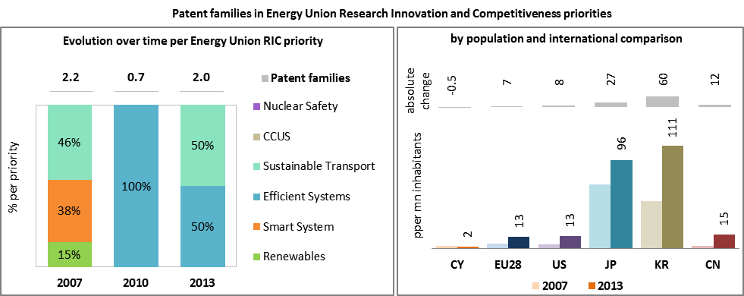

*(Data sources: Patent data based on the European Patent Office PATSTAT database[11]. Private investment as estimated by JRC SETIS. Detailed methodology available from the JRC[12].)*

* 1. **Competitiveness**

In 2013 Energy costs shares in total production costs for industry and services were more than twice as big as EU 25 despite the lack of energy intensive industries. Lack of natural gas forces all industry and services to rely on oil and oil products; Cyprus economy is therefore vulnerable to oil price volatility.

Electricity prices paid by industrial users were in 2016 above EU average. From 1 September 2017, new retail regulated tariffs have been implemented. Charges based on “Maximum Demand” applied previously in Commercial and Industrial Retail Tariffs have been abolished, while Seasonal Time-of-Day (STOD) Tariffs were introduced.

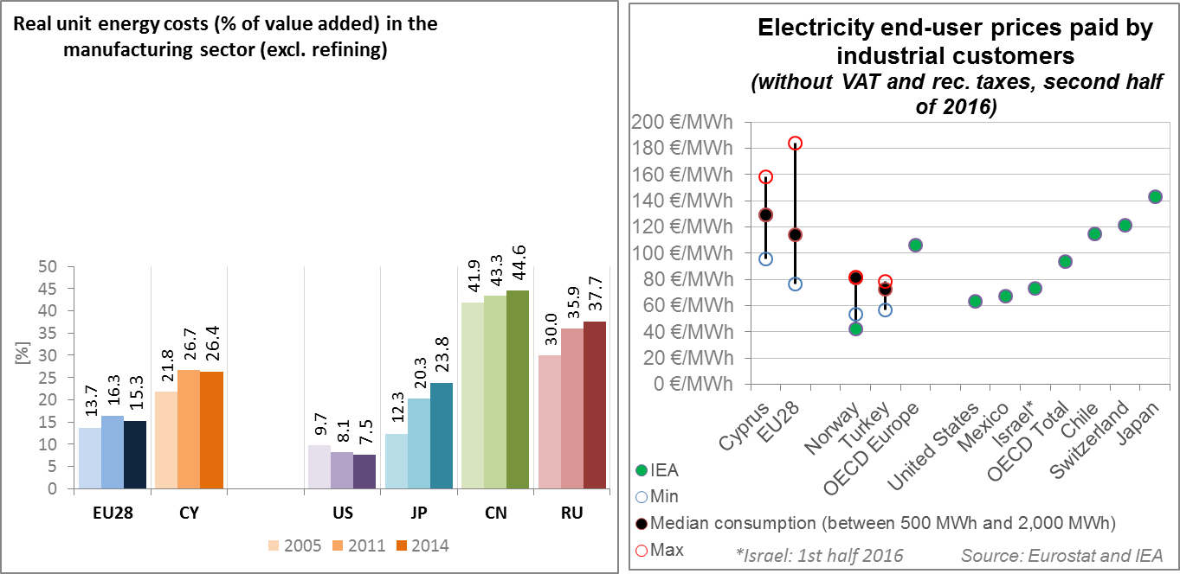

*(source: ECFIN) (source: ESTAT and IEA)*

Regarding the competitiveness in wind and solar energy technologies, Cyprus seems to have underutilised its potential to become a major player in the solar energy sector. As indicated by the revealed comparative advantage indicator[13] well above 1, the Cypriot economy has a strong revealed competitive advantage in solar PV, in both absolute terms and vis-à-vis the EU as a whole. This comparative advantage has been concentrated in the sub-sector of solar component production. Cyprus' relative export success in this niche has been fading however with the strong rise of China (together with Taiwan and Malaysia) as major exporters. The relatively late installation of solar power generation capacity (despite Cyprus' excellent conditions for solar power generation) does not seem to have played a major role in view of the relatively tiny size of its "home market" for solar components. The relative trade balance[14] figures show that Cyprus has been a net importer of solar PV items; the trade deficit has increased over time with Cyprus' building more solar energy plants. The figures show that Cyprus is not specialised in wind energy technologies. It has had a very weak competitiveness performance, in both absolute terms and vis-à-vis the EU as a whole. The relative trade balance confirms that Cyprus is an importer of wind components, significantly exceeding the EU average.

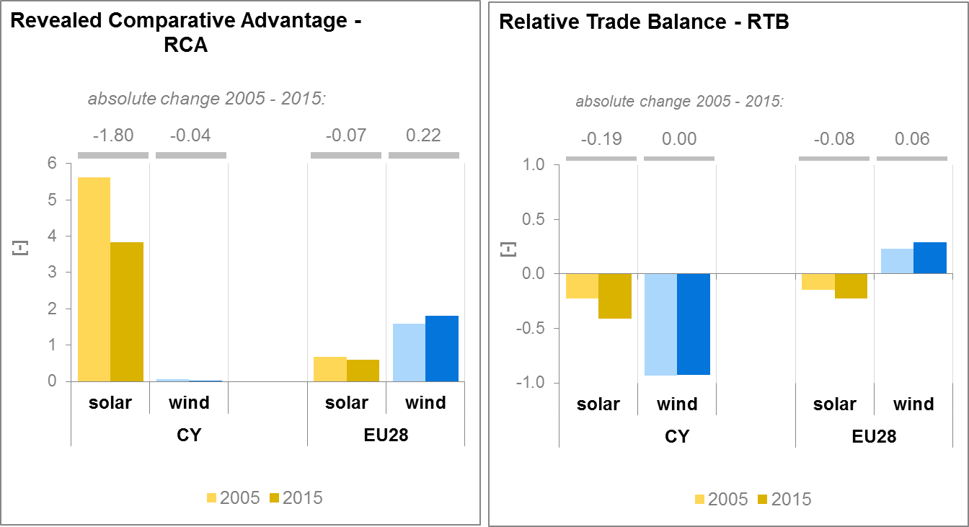

*(source: UN comtrade)*

1. **Regional and local cooperation**

Cyprus promotes initiatives for regional cooperation with EU and/or non-EU countries. There are already two projects (East Med pipeline, and the EuroAsia Interconnector) which have qualified as Projects of common interest (PCIs) on the basis inter alia of their cross-boundary effect.

In addition, Cyprus is actively pursuing wider (trilateral and quadrilateral) regional cooperation in the energy and hydrocarbons sector. The Memorandum of Understanding between Cyprus-Greece-Israel in August 2013 and the Cyprus-Greece-Israel-Italy Declaration of Tel Aviv for the East pipeline in April 3rd 2017 are sound examples.

European Territorial Cooperation – 'Interreg' – under EU cohesion policy provides further opportunities for cross-border, transnational and interregional cooperation, including in the Energy Union areas.

Cities and urban areas have a key role in the energy and climate challenge. The Urban Agenda for the EU, established by the Pact of Amsterdam in May 2016, better involves cities in the design and implementation of policies, including those related to the Energy Union. It is implemented through Partnerships, in which the Commission, Member States, cities and stakeholders work together on a number of important areas, including on Energy Transition, Urban Mobility, Air Quality, Climate Adaptation and Housing. Cyprus is participating in the partnership on Urban Mobility, as member.

By 2016, in the context of the Covenant of Mayors, the sustainable energy action plans delivered by 24 Cypriot municipalities had been assessed. Overall, these 24 municipalities cover about 470 thousands inhabitants. These municipalities committed to reducing GHG emissions by 27.7% by 2020 (as compared to 1990 baseline), in line with was committed on average at EU level, but leading to higher emissions per capita.

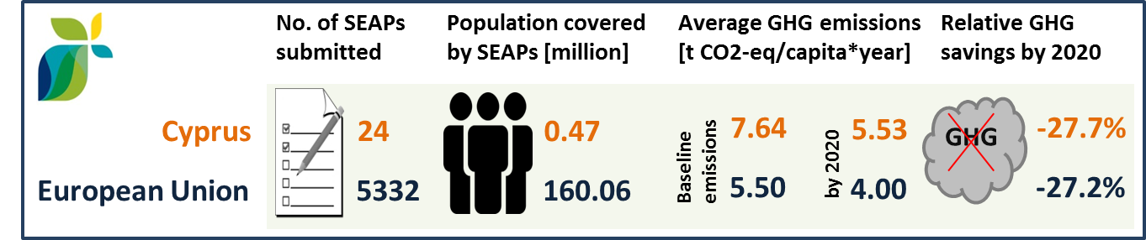

*(source: JRC 2016. Notes: SEAP=sustainable energy action plan, GHG=greenhouse gas emissions)*

In Cyprus, by September 2016, no cities have yet committed to conduct vulnerability and risk assessment and develop and implement adaptation plans in the framework of the Covenant of Mayors for Climate and Energy.

1. **Cohesion policy and EU clean energy investments**

EU cohesion policy makes a key contribution to delivering the Energy Union objectives on the ground, including important investment possibilities to implement energy policy objectives in Cyprus which are complemented by national public and private co-financing, aiming at optimal leverage. It also ensures integrated territorial solutions to energy and climate challenges, supports capacity building and provides technical assistance.

Over 2014-2020, cohesion policy is investing some EUR 45 million in energy efficiency improvements in public and residential buildings and in SMEs, as well as in high-efficiency cogeneration and district heating in Cyprus. Cohesion policy is also investing significantly in R&I and in SME competitiveness in Cyprus, based on the national strategy for smart specialisation. For Cyprus, the strategy includes a focus on sustainable energy. At this stage, the allocations foreseen for investments in R&I and adoption of low-carbon technologies in Cyprus are not specified, but should become available in line with the evolving content of the smart specialisation strategy. A further estimated EUR 82 million is invested in supporting the move towards an energy-efficient, decarbonised transport sector.

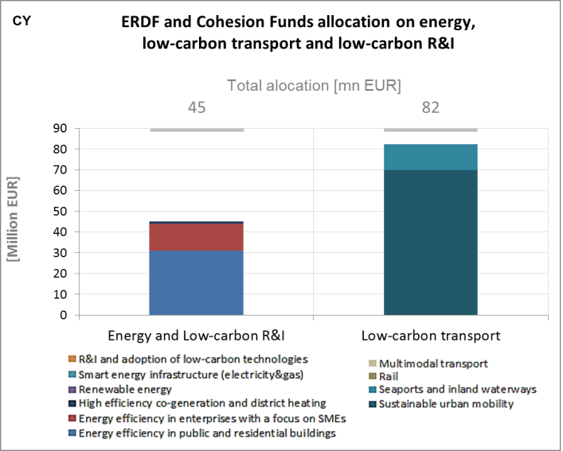

*(source: DG REGIO)*

These investments are expected to contribute to around 3,500 households with improved energy consumption classification and a decrease of around 3,000,000 kWh per year of primary energy consumption of public buildings. Overall, the EU Cohesion policy investments in Cyprus over 2014-2020 are expected to contribute to an estimated annual decrease of GHG emissions of around 4,000 tonnes of CO2eq.

In the context of the review of the cohesion policy funding for the period 2017-2020 (the so called "technical adjustment"), Cyprus has decided to allocate an additional amount of EUR 13 million for supporting the shift towards a low-carbon economy, for the use of financial instruments to support energy efficiency in the public sector and households.

For example, during 2007-2013 the Operational Programme "Sustainable development and Competitiveness" co-funded by Cohesion Fund (CF) and European Regional Development Fund (ERDF) co-financed actions in view to increase the contribution of renewable energy sources to the energy balance, in particular installation of photovoltaic systems in public buildings, schools and camps, installation of hot water systems or heating from solar panels in public buildings, and development of electrical and thermal energy generation systems, utilizing solar power through the creation of solar thermal plants. The total budget for these actions amounted to some EUR 5 million. The average annual electricity output produced by photovoltaic systems installed in public buildings amounts to 2,257,877 kWh. In addition, the additional renewable energy generation capacity is 1.5MW, compared to 1.4MW which was the target value of the indicator by 2015.

Through its support to sustainable transport systems, the Connecting Europe Facility (CEF) also contributes to the goals of the Energy Union. Following Cypriot participation in the CEF – Transport 2014-2015 Calls, the Cypriot action portfolio comprises 9 signed grant agreements, allocating EUR 5.1 million of actual CEF Transport Funding to Cypriot beneficiaries (state-of-play February 2017)[15]. The transport mode which receives the highest share of funding is multimodal transport action (40.1% of actual funding). The action aims to facilitate freight operations by building a multimodal logistic and freight platform in Larnaca International Airport. The platform will ensure easy access to the main roads, the Larnaca Port and the existing passenger terminal, in order to encourage exports and transhipment from the island to the rest of Europe, the Middle East and Africa.

Since Cyprus is an island, the maritime sector is well represented in its CEF portfolio with 55.6 % of all Cypriot actions. In this context, Cyprus focuses on reducing the environmental impact of maritime transportation via the participation in projects that promote the use of LNG as fuel and the use of on shore power supply. The most significant Cypriot action in terms of actual funding is a pilot action to test and enhance a sustainable intermodal transport and logistics system for freight movement between Mediterranean and Northern European destinations by rail and sea.[16]

1. The indicators used in this country factsheet largely build on indicators developed for the Commission Staff Working Document "Monitoring progress towards the Energy Union objectives – key indicators" (SWD(2017) 32 final) <https://ec.europa.eu/commission/sites/beta-political/files/swd-energy-union-key-indicators_en.pdf>
2. Gross value added and employment in NACE sectors D-Electricity, gas, steam and air conditioning supply and H-Transportation and storage
3. National accounts, Eurostat
4. Avoided GHG emissions mentioned here have a theoretical character as these contributions do not necessarily represent 'net GHG savings per se' nor are they based on life-cycle assessment or full carbon accounting.
5. European Environment Agency, 2016, [Air Quality in Europe – 2016 Report](https://www.eea.europa.eu/publications/air-quality-in-europe-2016), table 10.2. The report also includes details as regards the underpinning methodology for calculating premature deaths.
6. Directive 2008/50/EC of the European Parliament and of the Council of 21 May 2008 on ambient air quality and cleaner air for Europe, OJ L 152, 11.6.2008, p.1-44
7. Compliance data as reported by the Member States as part of their official annual air quality report for the calender year 2015 (available on the European Environment Agency's (EEA) Eionet/Central Data Repository), <http://cdr.eionet.europa.eu/cy/eu/aqd>
8. See also the EU Environmental Implementation Review Country Report for Cyprus, SWD(2017)36 final of 3.2.2017
9. National emission data as reported by the Member States to the EEA (available on the EEA's Eionet/Central Data Repository), <http://cdr.eionet.europa.eu/cy/eu/nec_revised>
10. In the context of this document, the term 'patent' refers to patent families, rather than applications, as a measure of innovative activity. Patent families include all documents relevant to a distinct invention (e.g. applications to multiple authorities), thus preventing multiple counting. A fraction of the family is allocated to each applicant and relevant technology.
11. <https://www.epo.org/searching-for-patents/business/patstat.html#tab1>
12. <https://setis.ec.europa.eu/related-jrc-activities/jrc-setis-reports/monitoring-ri-low-carbon-energy-technologies>
13. The RCA index for product "i" is defined as follows: ${RCA}_{i}=\frac{\frac{X_{j,i}}{\sum_{i}{X_{j,i}}}}{\frac{X_{w,i}}{\sum_{i}{X_{w,i}}}}$ where $X$ is the value of exports, and j is the country and w is the reference group, the World economy. 2005 refers in the text to the indicator average over the 2000-2009 period, while 2015 represents the average over the 2010-2016 period. The same applies for the RTB indicator - see below.
14. The RTB indicator for product "i" is defined as follows: ${RTB}_{i}=\frac{X_{i}-M_{i}}{X_{i}+M_{i}}$ where $X_{i}$ is the value of product's "i" exports and $M_{i}$ imports.
15. Note that European Economic Interest Groups and International Organisations are excluded from the analysis.
16. Source: INEA